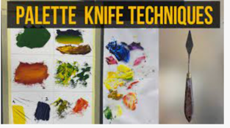

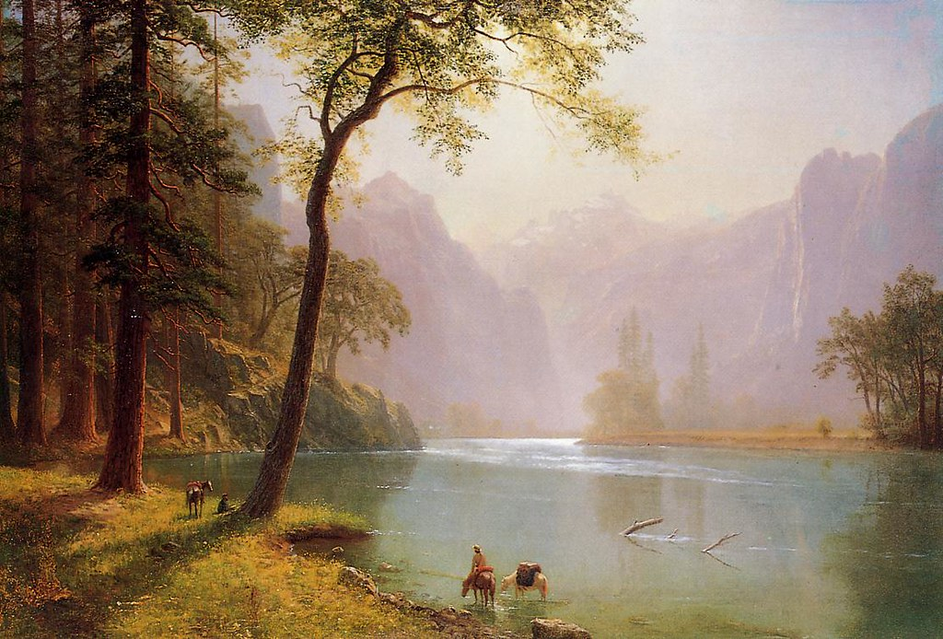

https://youtu.be/DinoW2tGUrw?feature=shared

Key Vocabulary
Foreground | The part of a view that is nearest to the observer, especially in a picture or photograph
Background | The part of a picture, scene, or design that forms a setting for the main figures or objects, or appears furthest from the viewer
Mirror line | A line which can be drawn onto a shape to show that both sides have exact reflective symmetry
Construction line | The line with which the projection of the elevation of buildings and/or construction works must coincide
Reflection | Throwing back by a body or surface of light, heat, or sound without absorbing it
cityscape | The visual appearance of a city or urban area; a city landscape

This Photo by Unknown Author is licensed under CC BY-SA-NC
This Photo by Unknown Author is licensed under CC BY-NC
This Photo by Unknown Author is licensed under CC BY-SA-NC
This Photo by Unknown Author is licensed under CC BY-NC
What will I learn by the end of this topic?
- explore and experiment with perspective in landscape artwork
- use Pop art techniques and layering to create a 3D cityscape
- understand how to use a palette knife to paint a textured cityscape
- explore how to create reflections of cityscapes on water
- use pen and ink to create a landscape drawing
Palette knife techniques



